I had the same issue with another assignment. If I try to show HTML file directly from the system hard-drive, I get an error “null has been blocked by CORS policy", it can’t fetch the JSON data.

For solve this issue, I need a web sever because my JavaScript code is fine. So, I choose the Live Server extension on Visual Studio Code.

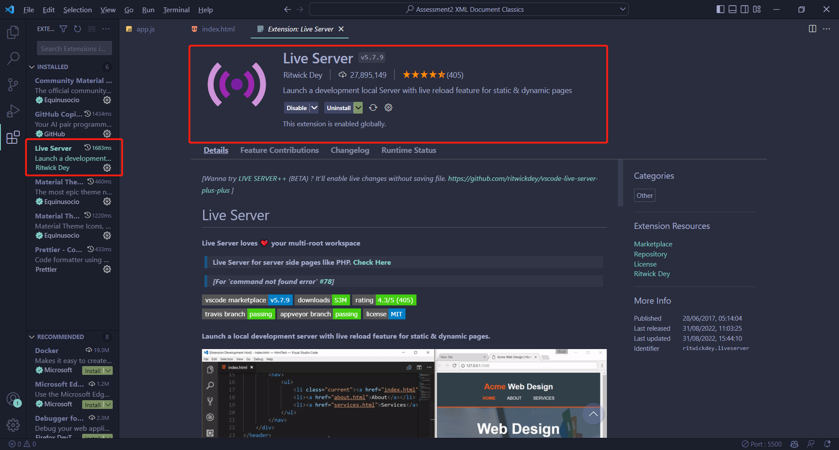

If I host my page on this local development sever like the pictures below, this issue is gone. Now my HTML file can read the JSON file on the browser.

